DATABASE LAB 13

Name: Ahmed Kasteer

Roll Number: 20F-0336

Section: 4D

Q1

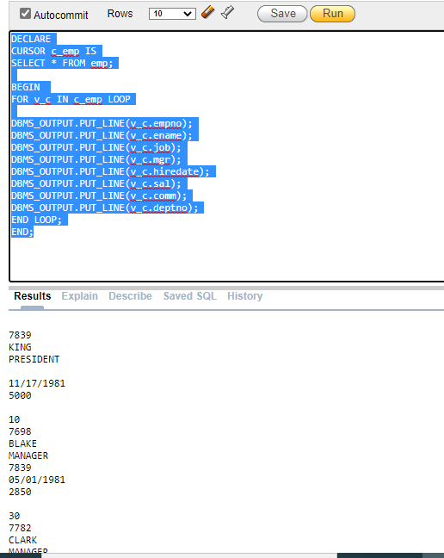

Q2:

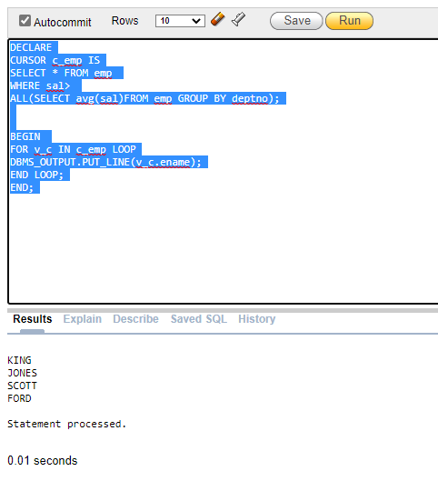

Q3:

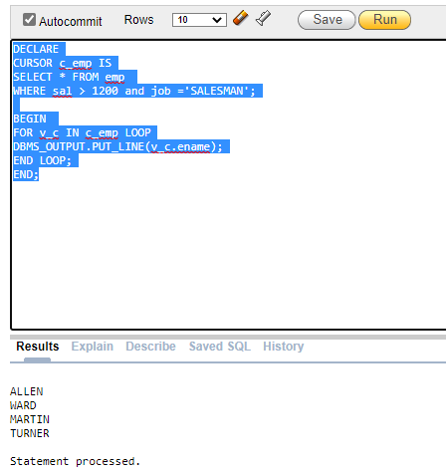

Q4:

